First Brochure

XXV Annual Conference of the
Electron Microscope Society of India
on
Electron Microscopy and Allied Fields
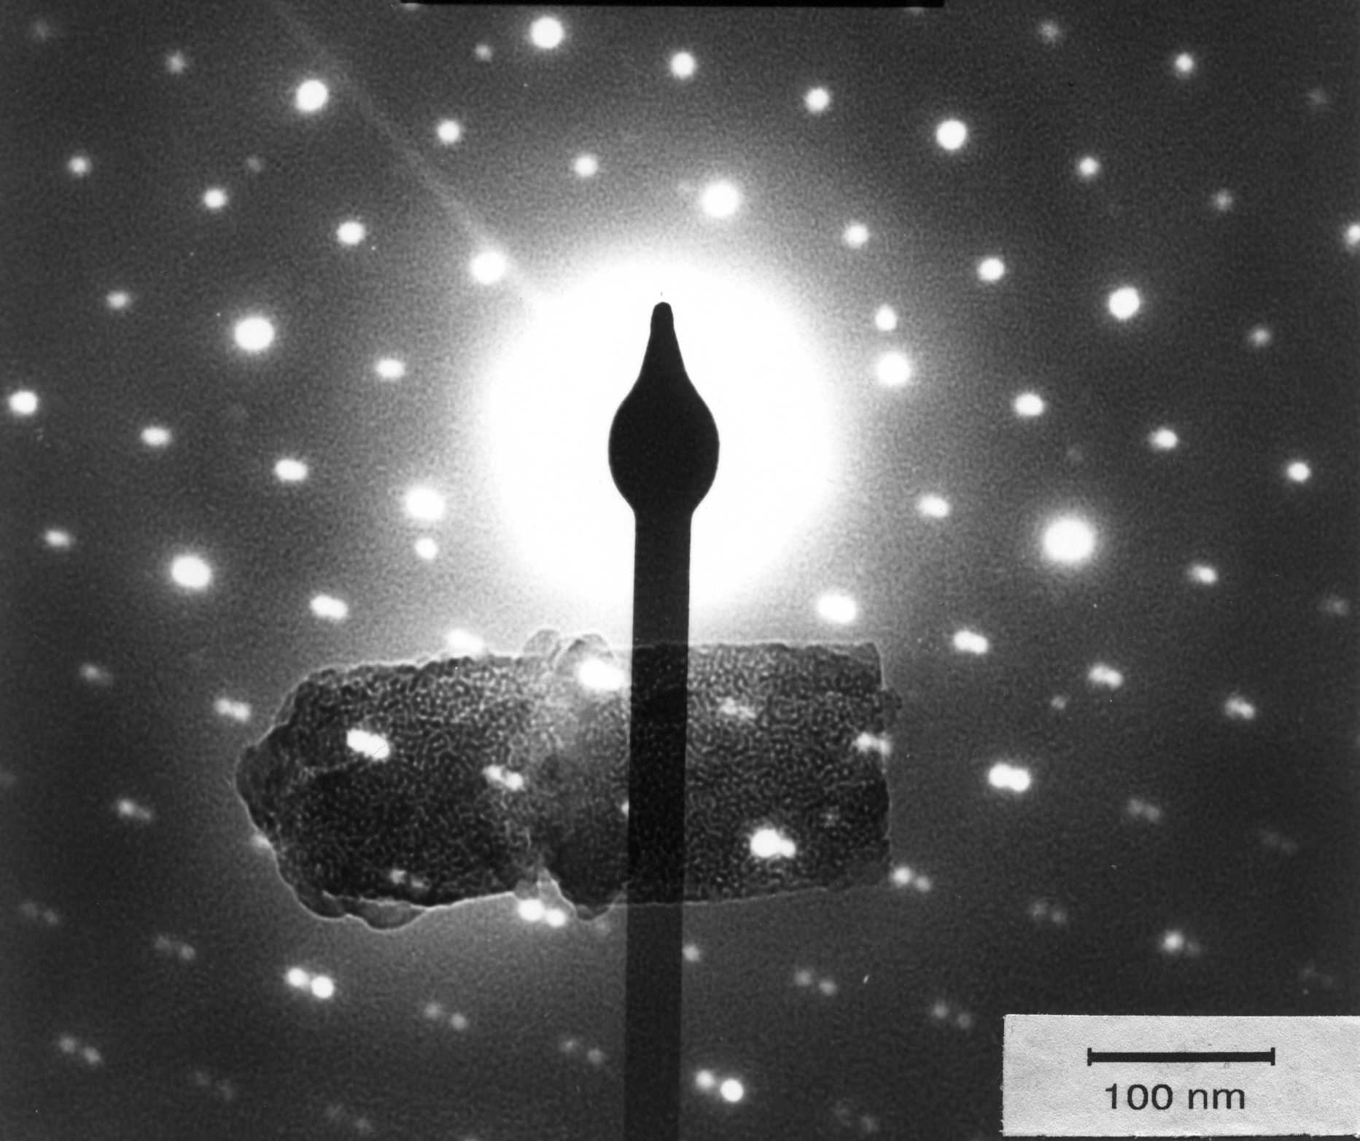19 to 22 February, 2002 at IIT-Bombay

Co-Sponsored by:
Indian Society for Surface Science and Technology, Western India Chapter (ISSST.WIC)

EMSI-2002
c/o Department of Chemical Engineering
IIT Bombay, Powai, Mumbai-400076 INDIA

email: emsi@cc.iitb.ac.in
web: http://www.che.iitb.ac.in/faculty/jb/emsi
fax: +91 22 5726895 or +91 22 5723480
phone: +91 22 5767207
Invitation to EMSI-2002
On behalf of the Organizing Committee, we have immense pleasure in inviting you to IIT-Bombay at Powai, Mumbai for the 25th Annual Conference of the Electron Microscope Society of India (EMSI).
We wish to benefit from your expertise and seek your esteemed support for using the EMSI platform for dissemination of current knowledge on Electron Microscopy and Allied Fields. Several eminent Electron Microscopists and Application Specialists from India and abroad are also expected to participate. We are aiming to have a successful meeting of EM experts, students and industry representatives.
Mumbai's climate will be pleasant in February. Besides the technical events, we hope you will enjoy visiting Mumbai's many remarkable institutions, impressive buildings, long beaches and heritage spots. IIT Bombay will feel honoured to receive you as a guest participant and the local organizing committee will try to make every effort to live upto your expectations of an excellent conference.

Prof. Ashok Misra Prof. Jayesh Bellare
Patron, EMSI-2002 Convenor, EMSI-2002
Director, IIT Bombay Head, BioMedical Engineering

Prof. A.Q. Contractor Prof. Raman S. Srinivasa
Secretary, EMSI-2002 Secretary, EMSI-2002
Head, RSIC Professor, Met. & Mat. Sci.

Important Dates & Deadlines
- Call for participation/abstracts through the first brochure 31 July 2001
- Receipt of abstracts with completed abstract form 15 October 2001
- Acceptance of abstracts and call for full papers 1 December 2001
- Receipt of full papers 1 January 2002
- Receipt of registration forms and fees 1 January 2002
- Registration with late fees 15 January 2002
- Receipt of entries for photomicrograph contest 15 January 2002
- Beginners workshop 19 February 2002
- Conference dates 20-22 February 2002

XXV ANNUAL EMSI CONFERENCE ON
ELECTRON MICROSCOPY AND ALLIED FIELDS
(FEBRUARY 19-22, 2002)

The XXV Silver Jubilee Annual Meeting and International Conference on Electron Microscopy and Allied Fields will be held at IIT Bombay, Mumbai from 19-22 February, 2002. The conference offers an opportunity to cover a wide range of subjects:

- Soft matter & Complex fluids
- Nanomaterials & nanoparticles
- Physical sciences
- Materials science
- Earth sciences
- Biological sciences
- Cell biology
- Thin film technology
- Aquatic sciences
- Metallurgy
- Polymers and composites
- Biomedical engineering
- Earth sciences
- Electron diffraction & analysis
- Surface morphology
- Entomology
- Biomaterials
- New techniques
- Low-vacuum methods
- Image processing
- Web based microscopy
- Optical Light microscopy
- Novel types of microscopy
- Scanned probe microscopy:
- Confocal, multi-photon
- FISH
- AFM, tunneling
- Thermal, electrochemical, etc.
- Workshops on specialized techniques

You are cordially invited to participate in this conference.

- Your participation is welcome through presentation of research papers on these and related topics, as delegates, and as exhibitors.
- Students and Research Scholars are welcome.
- Our goal is to provide an opportunity for interaction and collaboration between electron microscopists and industry/academia/laboratories for microscopy-related research, development and quality monitoring.
- Our goal is also to promote young active workers in the field by giving them an opportunity to interact with specialists, senior colleagues and equipment suppliers.
- A training workshop to initiate researchers in electron microscopy is planned.
- Advanced workshops to illustrate some specialized techniques are planned.
- Manufacturers and representatives of microscopes, accessories, supplies and consumables are invited to present details of new equipment by means of exhibition, demonstration, lectures and advanced workshops.
- Full papers submitted by the deadline will be published in the proceedings. Full papers that are presented may also be published (after further review) in a special issue of a reputed journal.

Registration Information
Registration forms are located later in this brochure. They are also available on the web at www.che.iitb.ac.in/faculty/jb/emsi . There are sections relating to: delegate registration, abstract submission, workshop registration, and accommodation.

Delegate Registration Package
All "Full Registrants" will have access to the following
- All scientific sessions of the conference.
- Competitions (e.g., Best Micrograph) of all types.
- Technical exhibitions.
- Working lunch and two teas per day at conference site.
- Sponsored dinners, if any.
- Each registrant will receive the conference kit containing final programme, abstracts/proceedings, stationery and other relevant information brochures.
All "Accompanying Person Registrants" will have access to the following
- Working lunch and two teas per day at conference site.
- Sponsored dinners, if any.

Delegate Registration Fee for Conference
 | By November 15, 2001 | After November 15, 2001
Indian Registrant | Rs. | Rs.
Full Registrant | 1500.00 | 2000.00
Life Member (of EMSI) | 1200.00 | 1500.00
Student / research scholar* | 300.00 | 500.00
Accompanying Person | 600.00 | 600.00
Corporate Registration (upto 3 persons) | 8000.00 | 10,000.00
Foreign Registrant | US$ | US$
Full Registrant | US$ 250.00 | US$ 300.00
Accompanying person | US$ 200.00 | US$ 200.00
- On-site registration will be available, subject to vacancies. Therefore, advance registration is highly recommended.
- *Research scholars and full time university students must provide proof by way of a letter from their college principal / university registrars stating their official student status.

Letter of Invitation
A "Letter of Invitation to attend the conference" will be sent to participants if indicated in the form provided. The invitation letter may be of use to participants to facilitate their getting travel funds from their own resources, for visas, for leave applications, etc., in order to attend the conference. The invitation letter does not imply any obligation of financial support from the organizing committee.
Information Regarding Presentations
Oral
Oral presentation will be of 12 minutes followed by 3 minutes of discussion. The following audiovisual equipment will be available: overhead projector, slide projector, LCD projector with PC containing CD-ROM drive, pointer.
Posters
Each poster will be allocated space of about one meter square (1m x 1m). Abstracts scheduled for poster presentation will be segregated into physical and biological sciences. The time schedule for setting up and taking down posters will be indicated in the program. Time will be set aside for a discussion session on Posters Presentation. At least one of the authors must attend the poster during this time to discuss the work presented.
All those wishing to make presentations (oral or poster) should submit an abstract.
Instructions to Author(s) for preparing posters
- Each poster will be given an area of about 1 meter square (1m x 1m).
- Panels would be provided for hanging/pasting the posters.
- The posters should be ideally made on several A4 size sheets. At the conference, each A4 sheet will be pasted or taped on the card sheets that would be provided. Alternatively, large posters of upto 1m x 1m may be made and brought.
- Card sheets of 1m x 1m would be provided so that the sheet in its entirety could be hung easily with the individual sheets / posters pasted on it.
- Include prominently on the poster the title of the presentation, the name of the author(s) and the institution where the work was undertaken.
- Present most results in graphical form.
- Character height recommendations: Title: 25 mm (approximately 72 point font), Headings: 10-16 mm (48 point), Text: 5-8 mm (24 point).
- Use glazed or glossy photographs for better visibility.
Instructions to Author(s) for submitting abstracts
- The abstract to be submitted is an extended abstract of two pages.
- Underline the name of the presenting author in the list of authors in the abstract.
- The presenting author must register and attend the conference.
- An author can present only one paper, but can be co-author on other papers. (Not applicable for invited papers.)
- Submit abstracts for oral as well as poster presentations.
- Please submit abstract as per prescribed format and include the abstract submission form.
- One original printout, one soft-copy (including soft-copy of figures in 300 d.p.i. uncompressed tiff format) and two hard-copies (printouts) must be submitted.
- Final choice for poster/oral presentation, and classification into category and session will rest with the conference organizers.
- Authors are urged to take every care before submitting the abstracts as they will be used in camera ready form, and hence authors will not get any galley-proofs.
- Statement(s), figures, images, micrographs and photographs in the article(s) is/are the responsibility of the author(s).
Text
- Abstract should be typed (preferably in Microsoft Word). A sample abstract is enclosed. Its soft-copy is available at: http://www/che.iitb.ac.in/faculty/jb/emsi
- Figures, illustrations, micrographs, etc., must be inserted within the file as scanned or computer-generated files. Supply figures as 300 d.p.i. uncompressed tiff files.
- Type the abstract within the limit of two A-4 (210 x 297 mm) pages
- The abstract should be of two pages.
- Page set-up is as follows: Spacing for all text: single; Font size: 12; Margins: Top and bottom: 25 mm(1 inch); Left and right: 30 mm(1.25 inch).
- Those using other paper sizes (8-1/2 x 11 inch) should adjust margins so that the text area matches the above (approx. 150 mm x 247 mm or 5.9 x 9.7 inches).
- Figures and illustrations with captions may be included in the running text.
- First line paragraph indentation to be 0.5 inch.
- Use Times New Roman font throughout.
- The title is centered 16-point bold with first character of each word in upper case.
- The authors are centered in 12-point font. List all authors on a line, then all affiliations on the next line. Underline the name of the presenting author.
- Type the text in 12-point font in single-spacing, left-justified (ragged right).
- For your reference, a sample abstract is enclosed. Its soft-copy in Word-97 format is available at: http://www/che.iitb.ac.in/faculty/jb/emsi
- Number the references in the order in which these appear in the text. List all references at the end in the format as per the example provided.
- Use high quality printer like laser or ink jet for the hard copy.
- Abstracts will be published in the "camera-ready" format submitted, without editing.

Figures
- Submit 3 original black and white prints of each photograph or drawing pasted in the right place. Please note that figure(s) of published articles will not be returned.
- Size of photomicrographs and drawings should not exceed 150 x 150mm.
- All figures and micrographs should be within the specified page margins.
- Use black ink for all charts and line drawings. Make decimals, broken lines, etc. strong enough for reproduction. Bar charts should be unidimensional and only in tones of grey or black.
- Use arrows to designate special features.
- Photomicrographs must show only the essential fields.
- Figure captions to be centered.
- Number the figures in the order in which these are mentioned in the text.
- Include soft copies of all figures/micrographs as 300 d.p.i. uncompressed tiff files. Name these files as fig1.tif etc., to correspond with the figure numbers in the text.

To complete your abstract submission, send:
- The properly completed official abstract submission form.
- One original abstract and two photocopies, all having the original photomicrographs (glossy) and drawings/tracings pasted in the correct places.
- One soft-copy (text, preferably in Word format, and figures as tiff files). This soft-copy can be sent on CD-ROM or by email (mailto: emsi@cc.iitb.ac.in).
- Please note that none of the submitted items will be returned.

Workshops
Beginners workshop
A one-day workshop for those starting electron microscopy will be held on 19-Feb-2002. It will consist of lectures and demonstrations on TEM and SEM. Due to the hands-on nature of this workshop, only a limited number of seats is available for this workshop and will be filled on a first-come basis.
Registration Fee for Beginners workshop (Limited number of seats available).
 | By November 15, 2001 | After November 15, 2001
Full Registrant | Rs: 1000.00 | Rs: 1,500.00
Student with proof | Rs: 200.00 | Rs: 300.00

Advanced workshops
Several advanced workshops covering specialized techniques or equipment are planned during the conference. Details will be sent in a subsequent mailing.

Technical Exhibition
An exhibition will be organized at the conference venue. Various manufacturers / representatives are invited to exhibit the equipment / literature / videos of their products. Confirmed list of exhibition participants in the exhibition will be on the web at: http://www.che.iitb.ac.in/faulty/jb/emsi
Cryo-Scanning Electron Microscopy of Myelins

Rajgopal C.Iyer, C.Manohar, Jayesh Bellare*
Department of Chemical Engineering, IIT Bombay, Powai, Mumbai-400076.

Myelin figures are non-equilibrium microstructures found in systems of amphiphilic molecules and water. They are known to be multi-lamellar rod-like structures where stacked bilayers of amphiphiles, alternating with water layers are wrapped concentrically around a rod-like core of water¹. Optical microscopy has been mainly used as a tool to visualize myelins and to study their growth behaviour. A scanning electron microscope has also been used to study the myelin figures in the surfactant egg-Phosphatidylcholine^{1,2,3,4}. Aerosol-OT / brine systems have also been studied^{5,6}. In the study reported here, we used a scanning electron microscope (SEM) to view the myelin figures under cryogenic conditions, in Aerosol-OT/water system. Until now, another surfactant microstructure, the liposome, has been used as carrier of drugs and moisturizers⁷. Work is being done to explore the possibility of using myelin figures for the purpose of encapsulation and reaction.
Myelins from soya-Phosphatidylcholine (Sigma-Aldrich) and AOT (Fluka) were grown on brass stubs with double distilled, de-ionized water. Samples were also tried on a copper plate, but the brass stubs gave better results. A JEOL JSM 6400 SEM in cryo mode was used to view the myelins. Liquid Freon-22 slush was used for cryogenic plunging⁸ and liquid nitrogen of high purity was used for cooling the SEM to cryo conditions and for sample stabilization.
A specially designed brass stub, 10 mm diameter and 7 mm height was developed for this work. A blind-hole, 6 mm diameter and 2 mm deep was drilled on the stub centre, where the surfactant was placed for myelin formation.
The SEM was cooled with liquid nitrogen and maintained at –130^{ο}C to –140^{ο}C. The surfactant was placed at the centre of the blind hole using a pair of clean forceps and a drop of double distilled, de-ionized water was put on top of the surfactant piece. After about 5 minutes, during which the myelins were allowed to grow, the stub was held in a plunging device and plunged at high speed into a reservoir of Freon-22 slush. The stub was kept in the Freon-22 slush for 5 minutes for temperature stabilization and then was quickly transferred into a vessel containing liquid nitrogen. The sample stub was cryo-transferred onto the pre-viewing stage of the cryo-SEM and fractured using an internal, dedicated fracture knife. Samples were viewed in SEI mode, some after cryo-coating with gold.
Figure 1a shows the presence of unfractured AOT myelins on a copper plate. It is seen in figure 1b that myelins grow out as tube-like structures from the main body of the surfactant when prepared on brass stubs. The fractured surface showed the internal multi-lamellar structure of the myelins (Figure 1c). Along with a few myelins that got fractured, some unfractured myelins were also observed and these were seen to be long tube-like structures (Figure 1b-arrow). Typically the size of the myelin figures were of the order of about 50 micrometers in length and about 15 micrometers in diameter, showing well defined, concentric bilayers (Figure 1d-arrow).
Work is being done to study the possibility of encapsulating material into the myelin figures, just like liposomes are used for encapsulation. Myelins are structures that are formed as a pre-cursor to liposomes. Thus, they exhibit behaviour similar to liposomes--like forming unique helical shapes⁹. Therefore, it is believed that encapsulation, and even reaction, could also be a possibility in myelins. This would yield nanoparticles and microstructured mesophases. The cryo-SEM method described here could be a powerful tool in such studies.
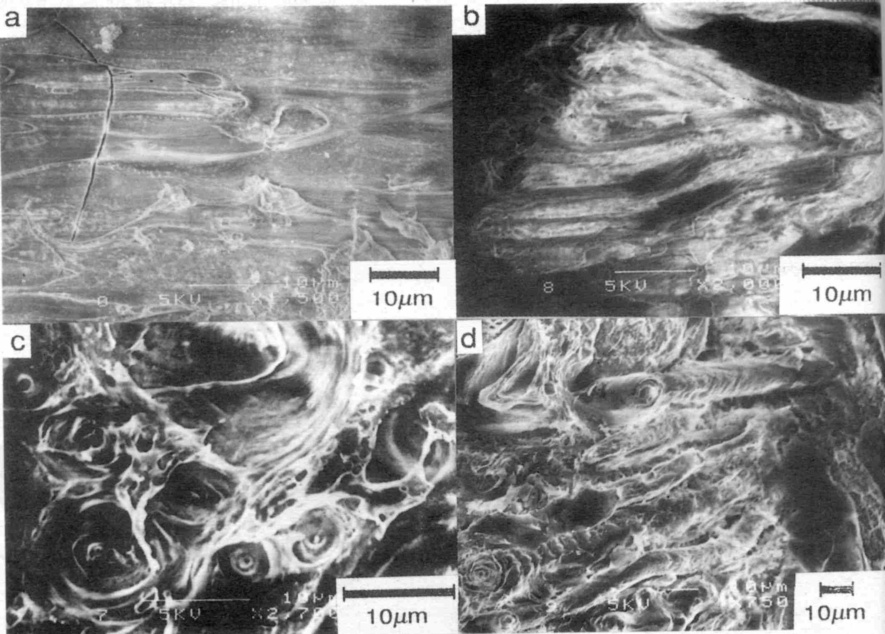
Figure 1: AOT myelins on a) copper plate and b-d) on brass stubs
References
- Sakurai .I et al, 1989, Cross-sectional view of myelin figures, Biochimica et Biophysica Acta, 985, 101-105.
- Mishima .K et al, 1984, The effects of pH and ions on the myelin figure formation in phospholipid-water system, Chem. Physics Letters, Vol.106, No. 6, May 11.
- Sakurai .I, 1985, Concentration gradient along the long axis of myelin figures of phosphatidylcholine, Biochimica et Biophysica Acta, 815, 149-152.
- Mishima .K, 1987, Growth rate of myelin figures of egg-yolk phosphatidylcholine, Biochimica et Biophysica Acta, 904, 149-153.
- Buchanan .M et al, 1998, Swelling and dissolution of lamellar phases: role of bilayer organization, Langmuir, 14, 7371-7377.
- Buchanan .M et al, 2000, Dynamics of interface instabilities in nonionic lamellar phases, Langmuir, 16, 3718-3726.
- Lasic, D.D., 1993, From Physics to Applications, Elsevier.
- Bellare J.R et al, 1993, A cryo-SEM technique developed and applied to surfactant liposomes, Proc. 51st Annual Meeting of the Microscopy Soc. of America.
- Ke-Chun Lin et al, 1982, Induction of helical liposomes by Ca²⁺-mediated intermembrane binding, Nature, Vol. 296, March 11.

Awards
Photomicrograph competition
The photomicrograph competition is open to all registered delegates on an entry fee of Rs.100/- for each entry. Each participant is allowed to submit a maximum of two photomicrographs. Each must be classified into the following categories:

- TEM materials science
- TEM biological science
- SEM materials science
- SEM biological science
- Other types of microscopy e.g., light/AFM/Confocal/etc.

Instructions for photomicrograph competition
- The size of each micrograph should be 8x10 inch, glossy
- The micrograph should be mounted (firmly stuck) on a thick, white, A4 size card.
- On the reverse of the card, neatly write/print the following:

Contestant's name, address, and laboratory

Brand & model of microscope used

Category of participation

Electron Optics magnification

Print magnification and micron bar

Description of object
- Submit your entry at the registration desk on the first day of the conference. Alternatively, send your entries together with a Demand draft in favour of "EMSI-2002" payable at Mumbai for Rs. 100/ per micrograph before 15 January 2002.
Entries in each category will be evaluated by an expert panel and winners announced. Awards will be given if sponsored. All entries must be free of any legal obligations, e.g., the copyright of the image must be with the submitting author.

Awards for best poster and oral presentation
Registrants making oral or poster presentation(s) will be eligible for awards in biological and material sciences (if sponsored). Guidelines for these awards will be announced at the time of registration.

How To Reach Mumbai & IIT-B
Mumbai is very well connected by air, road and rail to the rest of the country and to the world. Foreign travelers will need a visa. Please see the following web page for information on how to reach IIT-Bombay yourself from the main air / road / rail stations: http://www.iitb.ac.in/campus/howto/howtoget.html
Weather Conditions
The climate is pleasant during February. Light woolens may be required during the night but the days are warm. The day temperature is around 28 degrees Celsius and night temperatures are around 20 degrees Celsius. Rain is not expected.

Registration Form
Photocopies are acceptable. Please fill one form per person attending the conference or workshop.
This form is available on the web at: http://www.che.iitb.ac.in/faculty/jb/emsi
(A) Name and contact information
Delegate's Name: ___________________________________________________
Affiliation/laboratory: ______________________________________________
Address for communication: ________________________________________
_______________________________________________________________
________________________________________________________________
________________________________Pin____________________________
E-mail: ____________________________________________________
Fax: ____________________________________________________
Phone, office:_____________________________________________________
Phone, residence:___________________________________________________
Accompanying Person(s), if any:
Name(s) _____________________________________________________________
Name(s) _____________________________________________________________
(B) Conference registration for DELEGATE
You are registering as:
❑ Full Registrant  Student  EMSI member, membership no.: _________
(C) Letter of Invitation
❑ I require a letter of invitation.
(C) Special Requirements
Please specify any special requirements you may have and we will try our best to help
_____________________________________________________________________
(D) Abstract Presentation
I will be presenting the following as a  ORAL  POSTER presentation. Title:
_____________________________________________________________________
_____________________________________________________________________

(E) Beginner's Workshop Registration
❑ Full registrant  Student or research scholar with proof (enclose the proof)
(F) Advanced Workshop Registration
❑ I'm interested: send me more information when available  Not interested
(G) Accommodation Reservation Form
ACCOMMODATION CATEGORY:
Enter your preference below: (preferences cannot be assured)
❑ Student Hostel approximately Rs. 50 / day / person
❑ Staff Hostel approximately Rs. 100 / day / person
❑ Guest House approximately Rs.150 / day / person
❑ Hotel nearby IIT approximately Rs. 6000 / U.S. $150 / day / room plus taxes
Arrival date (tentative): _______________________________________________
Departure date (tentative): _____________________________________________
Important: Booking amount for accommodation for one day must be sent in advance. This amount is not refundable. Additional amounts must be settled during the stay with the Hotel / Hostel where accommodation is provided.
(H) Payment
Advance payment with this registration form is A MUST. Demand Drafts preferred.
DELEGATE Rs. __________ US$ __________
ACCOMPANYING PERSON(S) Rs. __________ US$ __________
BEGINNER'S WORKSHOP Rs. __________ US$ __________
ACCOMMODATION Rs. __________ US$ __________
TOTAL AMOUNT ENCLOSED Rs. __________ US$ __________
Enclose a bank draft in Rs. or US$ payable at a Mumbai bank favouring EMSI-2002.

Date: ________ Place: _____________ Signature:__________________________

Send to: EMSI-2002, c/o Department of Chemical Engineering,
IIT Bombay, Powai, Mumbai-400076, INDIA.

email: emsi@cc.iitb.ac.in
web: http://www.che.iitb.ac.in/faculty/jb/emsi
fax: +91 22 5726895 or +91 22 5723480

Abstract Submission Form
Photocopies are acceptable. Please fill one form per abstract.
This form is available on the web at: http://www.che.iitb.ac.in/faculty/jb/emsi
(A) Name and contact information
Presenter's Name: ___________________________________________________
Affiliation/laboratory: ______________________________________________
Address for communication: ________________________________________
________________________________________________________________
________________________________Pin____________________________
E-mail: ____________________________________________________
Fax: ____________________________________________________
Phone, office:_____________________________________________________
Phone, residence:___________________________________________________
(B) Title of paper/poster
_____________________________________________________________________
_____________________________________________________________________
_____________________________________________________________________
Indicate your preference:  ORAL  POSTER
Category number: (tick below)

-  Animal Sciences
-  Aquatic sciences
-  Biological sciences
-  Biomedical engineering
-  Cell biology
-  Cryo microscopy
-  Diagnostic electron microscopy
-  Diagnostic Virology
-  Earth Sciences
-  EELS
-  Electron diffraction & analysis
-  Entomology
-  Environmental analysis
-  Food Sciences
-  High Resolution Microscopy
-  Histochemistry
-  Image analysis and processing
-  Industrial quality control
-  Low-vacuum methods
-  Material Sciences
-  Metallurgy
-  Nanomaterials & nanoparticles
-  Nanostructure
-  Nanotechniques
-  New techniques
-  Novel types of microscopy
-  Optical Light microscopy
-  Physical sciences
-  Polymers and composites
-  Soft matter & Complex fluids
-  Surface morphology
-  Thin film technology
-  Tracer Techniques
-  Cosmetics
-  Food, flavours, fragrances
-  Pharmaceuticals
-  Ultrastructural studies
-  Web based microscopy
-  X-ray analysis
-  FISH
-  Scanned probe microscopy:
-  confocal, multi-photon
-  AFM, tunneling
-  thermal, electrochemical, etc.
-  Other: _______________

Send to: EMSI-2002, c/o Department of Chemical Engineering,
IIT Bombay, Powai, Mumbai-400076,INDIA.
email: emsi@cc.iitb.ac.in
web: http://www.che.iitb.ac.in/faculty/jb/emsi
fax: +91 22 5726895 or +91 22 5723480

