*IUTAM Symposium on Rrapid Granular Flows and Turbulent Particle Suspensions* 1

**Abstract Title**

Author(s)

*Affiliations*∗

Title should be in Times New Roman font, bold and of size 11. Corresponding email should be mentioned at the bottom of the page. Use Times New Roman font and size 11 for the address, abstract body and figure caption. Full Abstract should be limited to 1 page. Add references [1] at the end in the specified format. Save the file as pdf and upload the pdf to the link provided in the submission portal.

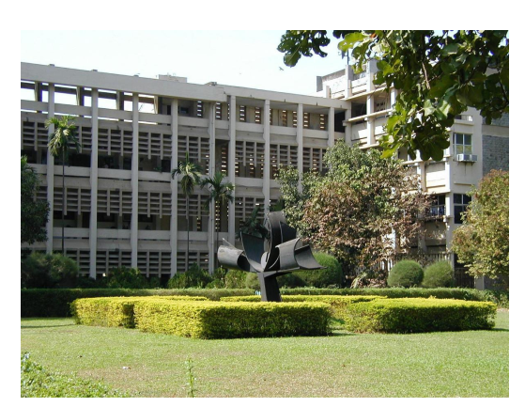

Figure 1: Caption of the Figure.

**References**

[1] Authors, Journal Name **volume**, page number at the start of article/article no. (year).